Share

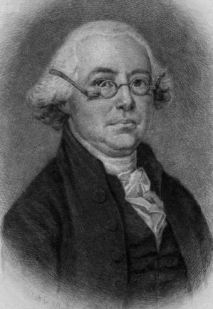
Founder James Wilson (1742-1798) signed both the Declaration of Independence and the U.S. Constitution, and was one of the six original justices appointed to the Supreme Court by President George Washington.

Philadelphia Inquirer
September 18, 2014
Reflect on nation's founding
By James Legee

As Americans look outward, they see a world in chaos. Syria is embroiled in a vicious civil war. Russia has annexed part of the Ukraine. President Obama is the fourth president to order a bombing campaign in Iraq.

Domestically, the nation is divided along partisan lines, and the economy has not recovered for many members of the working class. Given this bleak portrait, citizens wonder what America's role is in the world.

Though it's easy to feel adrift, we must remember this is not the first time Americans have felt this way. Looking back to our nation's founding, it's important to remember that America was once a new nation embroiled in partisan division and facing economic collapse. One Founding Father from Pennsylvania, James Wilson, offers particular wisdom for our chaotic world.

Wilson was born and educated in Scotland and immigrated to the colonies to pursue what we would today call the American dream. He studied law with John Dickinson, was one of only six men to sign both the Declaration of Independence and the U.S. Constitution, and was a member of the Committee of Detail, which drafted the actual articles of our Constitution. Wilson also lectured at what would become the University of Pennsylvania and was a Supreme Court justice. Today, visitors can pay their respects to him at the Christ Church graveyard in Philadelphia.

As the fight to ratify the Constitution began, Wilson gave a series of speeches encouraging Pennsylvania to approve the new government. Pointedly, Wilson acknowledged the great divide among the delegates from the 13 states:
"No small share of wisdom and address is requisite to combine and reconcile the jarring interests, that prevail . . . in a single community."

Each delegate approached the task of producing the new government with the interests of his own state in mind. Different climates, economic interests, and the ever-present threat posed from the great powers of the world, made the task difficult.

We know now that the Founders were successful, but how did these men of great intellect and ambition work out their deep-seated differences? Wilson is clear:

"Such a diversity of sentiment rendered a spirit of mutual forbearance and conciliation indispensably necessary to the success of the great work."

The source of this forbearance was a belief in a common set of principles.

Wilson articulated such principles during the Philadelphia convention. He was "for raising the federal pyramid to a considerable altitude, and for that reason wished to give it as broad a basis as possible. No government could long subsist without the confidence of the people." Legitimacy and sovereignty resided with the citizens. Wilson, as much as any other Founder, viewed the Constitution as the manifestation of the principle in the Declaration that "all men are created equal" and "endowed . . . with certain inalienable rights."

A nation created for such principles was unique in history. As Wilson remarked, founding a republic "left us almost without precedent or guide" that "may be derived from the constitution, and history, and experience of other nations."

Despite the lack of precedent, the young nation endured. Each year, during the events held to commemorate Constitution Day on Sept. 17, we celebrate not only the framing of our founding document, but we should also reflect upon what it will require to continue the success of our experiment in self-government.

As citizens united in "exercising [our] first and greatest power" of sovereignty and selecting our leaders, it serves us well to reflect on the origins of our Constitution. Wilson believed that the product of that muggy Philadelphia summer of 1787, self-government, "is unexampled as well as magnificent." Notably, this was never intended to be easy. We have a luxury, however, that Wilson and his colleagues did not have: the experience and wisdom of foregoing generations of Americans.

James Legee, who is the program director at the Freedoms Foundation at Valley Forge (www.freedomsfoundation.org), has a master's in political science from Villanova, where the public is invited to the university's Constitution Day Lecture, sponsored by the Philadelphia-based Jack Miller Center, at 4 p.m. Thursday. James Stoner, professor of political science at Louisiana State University, will speak on "Citizens or Exiles? Catholics and the Constitution."

Share

