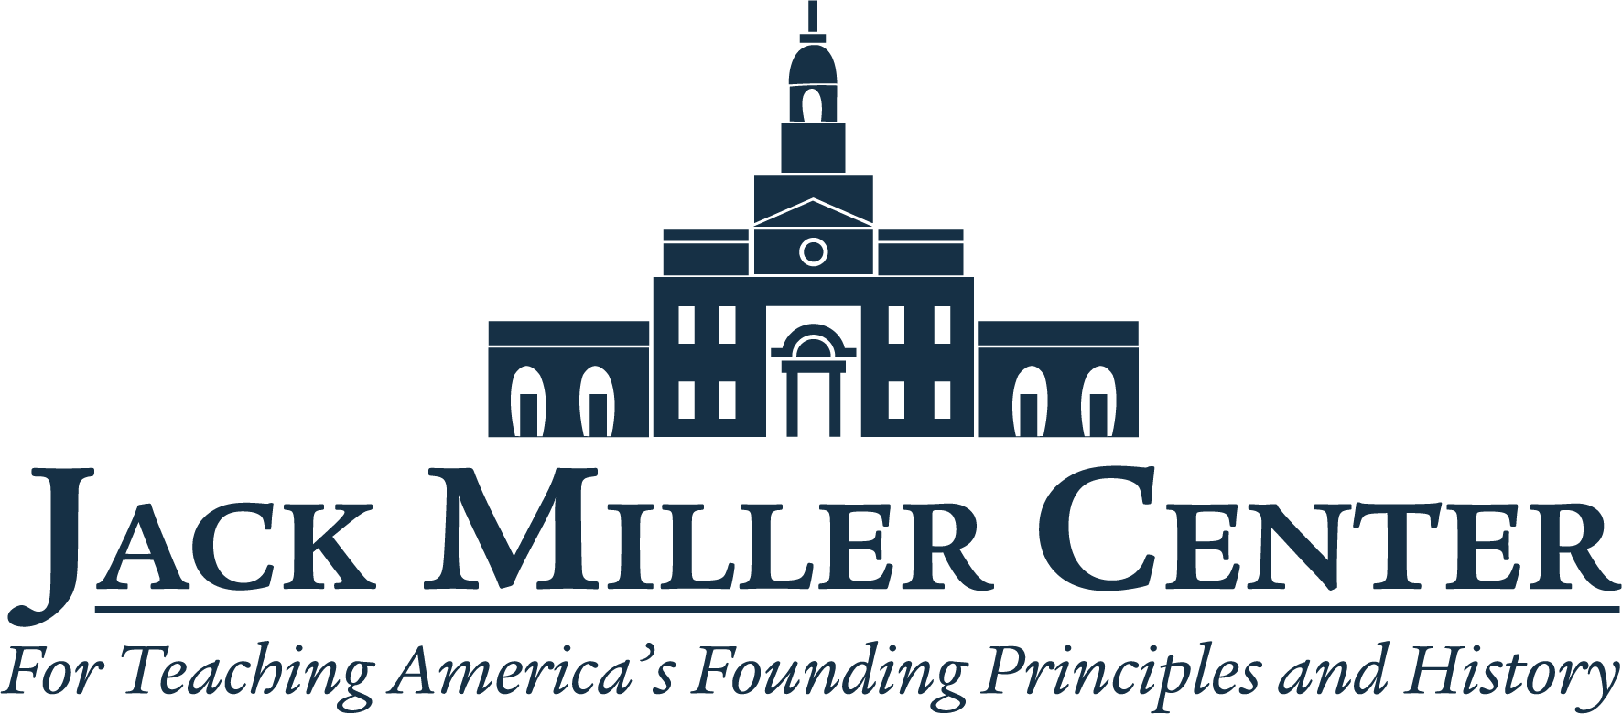
Jack Miller Center Announces Teachers Selected
for American Civic Tradition Fellowship

Philadelphia, PA — July 9, 2026: The Jack Miller Center, a civic education non-profit, today announced the 15 teachers from across the country chosen for its American Civic Tradition Fellowship, a yearlong program for middle and high school teachers designed to deepen their understanding of key American historical texts and strengthen their use of primary sources in the classroom.

The program kicks off with an in-person institute in Philadelphia from July 19-24 and will continue with virtual sessions for the next year. At the summer institute, seminars focused on American documents and primary sources let the teachers be students again, learning from the faculty and one another. Throughout the academic year, the cohort will participate in virtual sessions where each fellow presents a new lesson built from the summer readings, and the group will discuss testing new materials and share their successes and challenges.

The fellows include:
- Brett Almasi: Dover-Foxcroft, Maine (Foxcroft Academy)
- Louis Colletti: Balsam Lake, Wisconsin (Unity High School)
- Megan Edwards: Plaquemine, Louisiana (Math, Science, & Arts Academy-West)
- Lisa Gibson: Virginia Beach, Virginia (Ocean Lakes High School)
- Patrick Lawton: New London, Wisconsin (New London High School)
- Alyson McIrvin: Caldwell, Idaho (Heritage Community Charter School)
- Tyler Nice: Springfield, Oregon (Thurston High School)
- Anthony Nobles: Virginia Beach, Virginia (Plaza Middle School)
- Lamont W. Odufuye: Chicago, Illinois (Ignite)
- Steve Olson: Bloomington, Minnesota (Kennedy High School)
- Aisha Samuels: Sharpsburg, Georgia (East Coweta High School)
- Deborah Scott-Pease: Murrieta, California (Warm Springs Middle School)
- Lisa Tarkoff: Tustin, California (Red Hill Lutheran School)
- Mark Terra-Thomas: Franklin, Massachusetts (Franklin High School)
- Quintarries Upshaw: Pensacola, Florida (Workman Middle School)
“We’re thrilled to welcome the fellows to Philadelphia this July for an impactful week learning from top professors in the JMC network, said Lauren Altobelli, Director of the Founding Civics Initiative at JMC. “Fellows will return to their classrooms in the fall with deeper knowledge, new teaching strategies, and more confidence to educate students in American history and civics.”

###

ABOUT THE JACK MILLER CENTER
The Jack Miller Center is a nonpartisan, nonprofit organization advancing the work of scholars who teach and study the ideas, documents, and history we hold in common as Americans. We seek to grow the talent pipeline of university educators who teach the American political tradition, to forge new models for university-based training of K-12 civics and history teachers, and to build a diverse coalition of Americans to ignite a civic education renaissance.

For media inquiries or further information, please contact:
Marlee Promisel
Director of External Relations, Jack Miller Center
media@gojmc.org

